
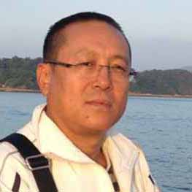
CHAIRMAN
DEPART IN CHIEF

Organization Growth & Coordination Depart
Harichandra Rai
CHAIRMAN
DEPART IN CHIEF

Organization Growth & Coordination Depart
Harichandra Rai

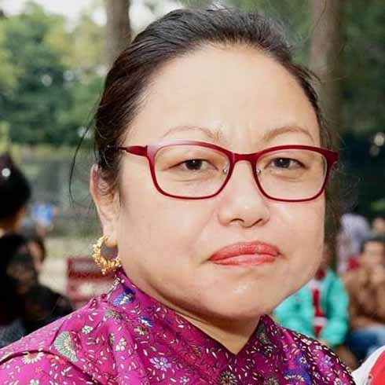
VICE-CHAIRMAN

DEPART IN CHIEF

Suptulung Renovation & Construction Depart
Chandraka Rai

VICE-CHAIRMAN

DEPART IN CHIEF

Suptulung Renovation & Construction Depart
Chandraka Rai

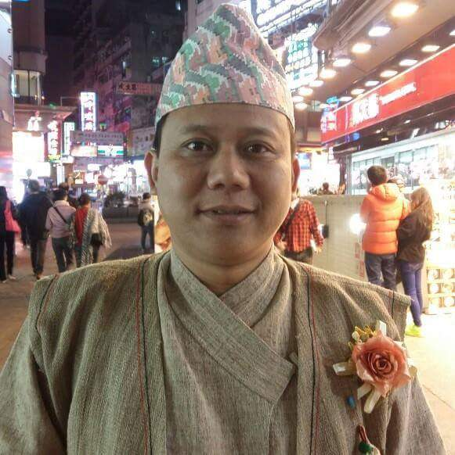
GENERAL SECRETARY

DEPART IN CHIEF

Youth Sport, Music & Communication Depart
Bajra Kumar Rai
GENERAL SECRETARY

DEPART IN CHIEF

Youth Sport, Music & Communication Depart
Bajra Kumar Rai

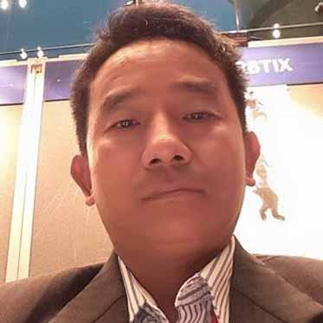
SECRETARY

DEPART IN CHIEF

Office Operation & Printing Depart

Gajendra Rai
SECRETARY

DEPART IN CHIEF

Office Operation & Printing Depart

Gajendra Rai


VICE-SECRETARY

DEPART IN CHIEF

Child, Women, Adult and Welcome Depart
Mrs. Pabita Rai

Valid: Till 25 Mar 2021
VICE-SECRETARY

DEPART IN CHIEF

Child, Women, Adult and Welcome Depart
Mrs. Pabita Rai

Valid: Till 25 Mar 2021

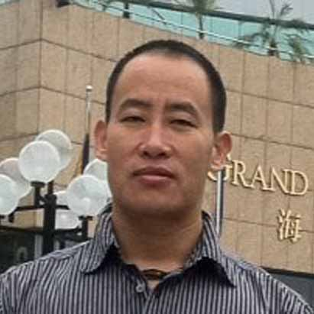
TREASURER

DEPART IN CHIEF

Asset & Fund-Raise Depart

Gangaram Rai
TREASURER

DEPART IN CHIEF

Asset & Fund-Raise Depart

Gangaram Rai

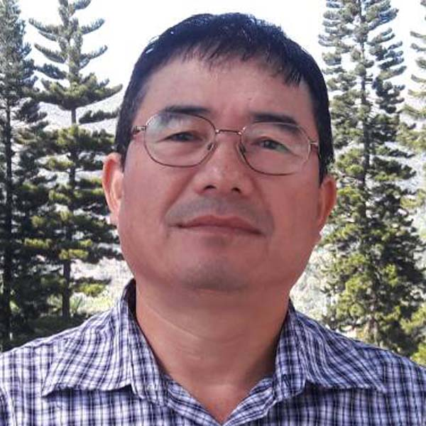
VICE-TREASURER

DEPART IN CHIEF

Waste Collection & Sanitation Depart

Kamal Rai

VICE-TREASURER

DEPART IN CHIEF

Waste Collection & Sanitation Depart

Kamal Rai

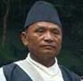
EXECUTIVE MEMBER

DEPART IN CHIEF

Kirat Religion Protection & Ritual Depart
Ramchandra Rai
EXECUTIVE MEMBER

DEPART IN CHIEF

Kirat Religion Protection & Ritual Depart
Ramchandra Rai

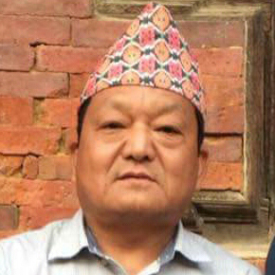
EXECUTIVE MEMBER

DEPART IN CHIEF

Shili Collection & Culture Depart

Rajendra Rai
EXECUTIVE MEMBER

DEPART IN CHIEF

Shili Collection & Culture Depart

Rajendra Rai

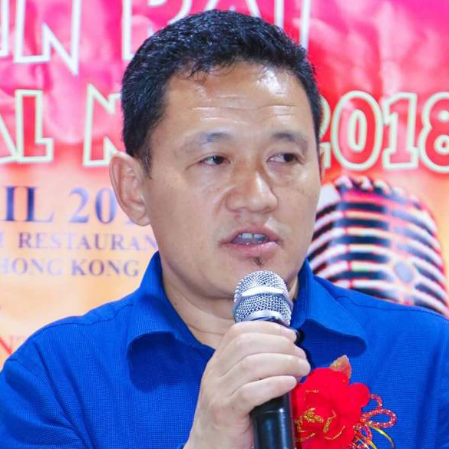
EXECUTIVE MEMBER

DEPART IN CHIEF

Sumnima Kitchen & Catering Depart

Jajin Rai
EXECUTIVE MEMBER

DEPART IN CHIEF

Sumnima Kitchen & Catering Depart

Jajin Rai

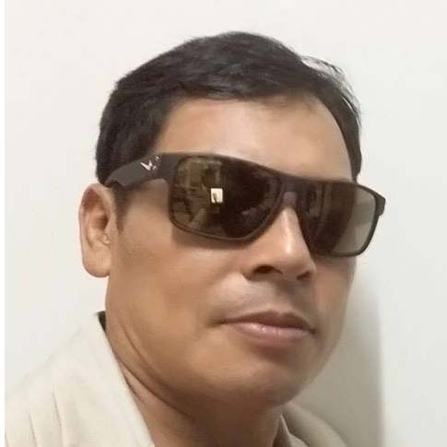
EXECUTIVE MEMBER

DEPART IN CHIEF

Historical Collection & Decoration Depart
Bishnu Rai
EXECUTIVE MEMBER

DEPART IN CHIEF

Historical Collection & Decoration Depart
Bishnu Rai

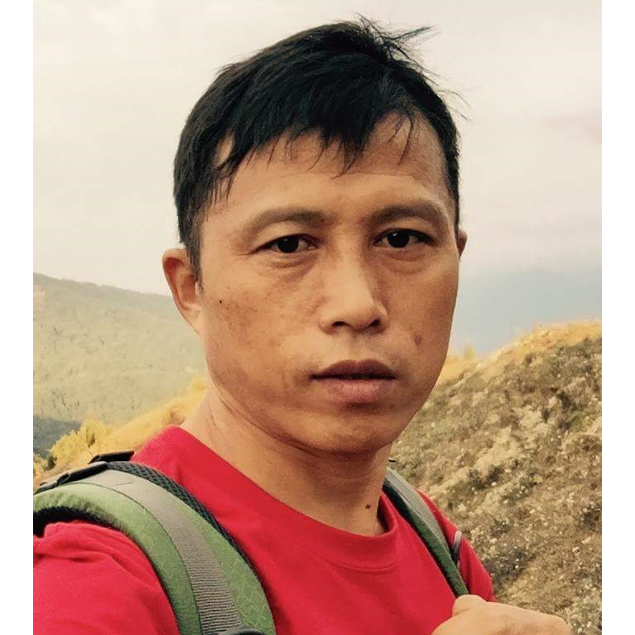
EXECUTIVE MEMBER

DEPART IN CHIEF

Shipping, Storage & Logistic Depart

Maniraj Rai
EXECUTIVE MEMBER

DEPART IN CHIEF

Shipping, Storage & Logistic Depart

Maniraj Rai


EXECUTIVE MEMBER

DEPART IN CHIEF

Guest Caring & Hospitality Depart

Pabi Bantawa Rai
EXECUTIVE MEMBER

DEPART IN CHIEF

Guest Caring & Hospitality Depart

Pabi Bantawa Rai

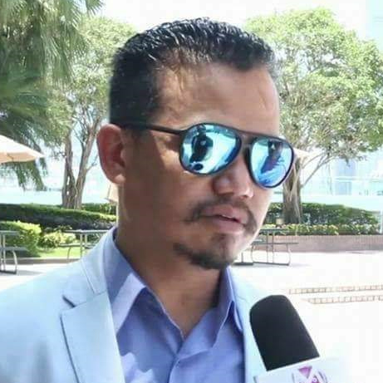
EXECUTIVE MEMBER

DEPART IN CHIEF

Emergency Help & Security Depart

Raju Rai
EXECUTIVE MEMBER

DEPART IN CHIEF

Emergency Help & Security Depart

Raju Rai

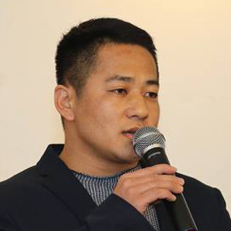
EXECUTIVE MEMBER

DEPART IN CHIEF

Business, Employment & Transport Depart
Dipendra Rai
EXECUTIVE MEMBER

DEPART IN CHIEF

Business, Employment & Transport Depart
Dipendra Rai


CHANCELLOR

MEMBER
Kirat Rai Intellectual Academy

Shashi Mada Rai
CHANCELLOR

MEMBER
Kirat Rai Intellectual Academy

Shashi Mada Rai

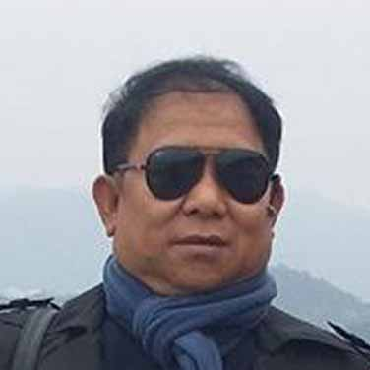
CHIEF-ADVISOR
MEMBER

Advisory Board of Kirat Rai Association

Rajin Rai

Valid: Till 25 Mar 2021
CHIEF-ADVISOR
MEMBER

Advisory Board of Kirat Rai Association

Rajin Rai

Valid: Till 25 Mar 2021

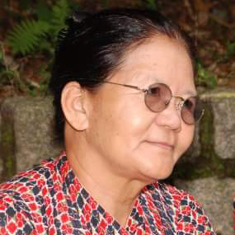
ADVISOR
COORDINATOR
(Traditional Food Section)

Sumnima Kitchen & Catering Depart

Basanta Kumari Rai
ADVISOR
COORDINATOR
(Traditional Food Section)

Sumnima Kitchen & Catering Depart

Basanta Kumari Rai


ADVISOR

MAIN COORDINATOR

Shili Collection & Culture Depart

Pitambar Rai
ADVISOR

MAIN COORDINATOR

Shili Collection & Culture Depart

Pitambar Rai

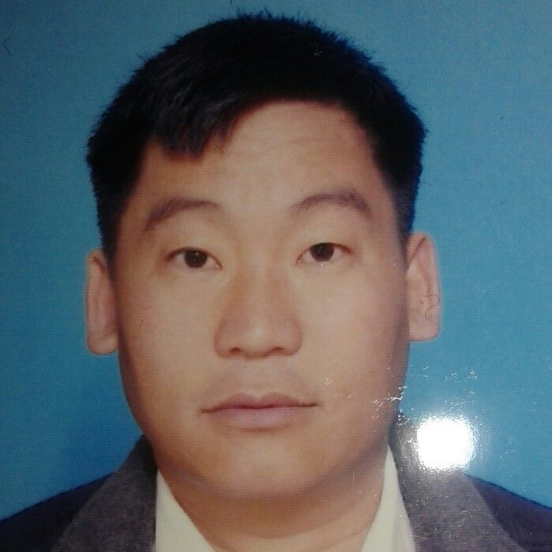
ADVISOR

MAIN COORDINATOR
Suptulung Renovation & Construction Depart

Dhiraj Kuamr Rai
ADVISOR

MAIN COORDINATOR
Suptulung Renovation & Construction Depart

Dhiraj Kuamr Rai


ADVISOR

MAIN COORDINATOR

Business, Employment & Transport Depart
Tilak Walahang Rai

ADVISOR

MAIN COORDINATOR

Business, Employment & Transport Depart
Tilak Walahang Rai

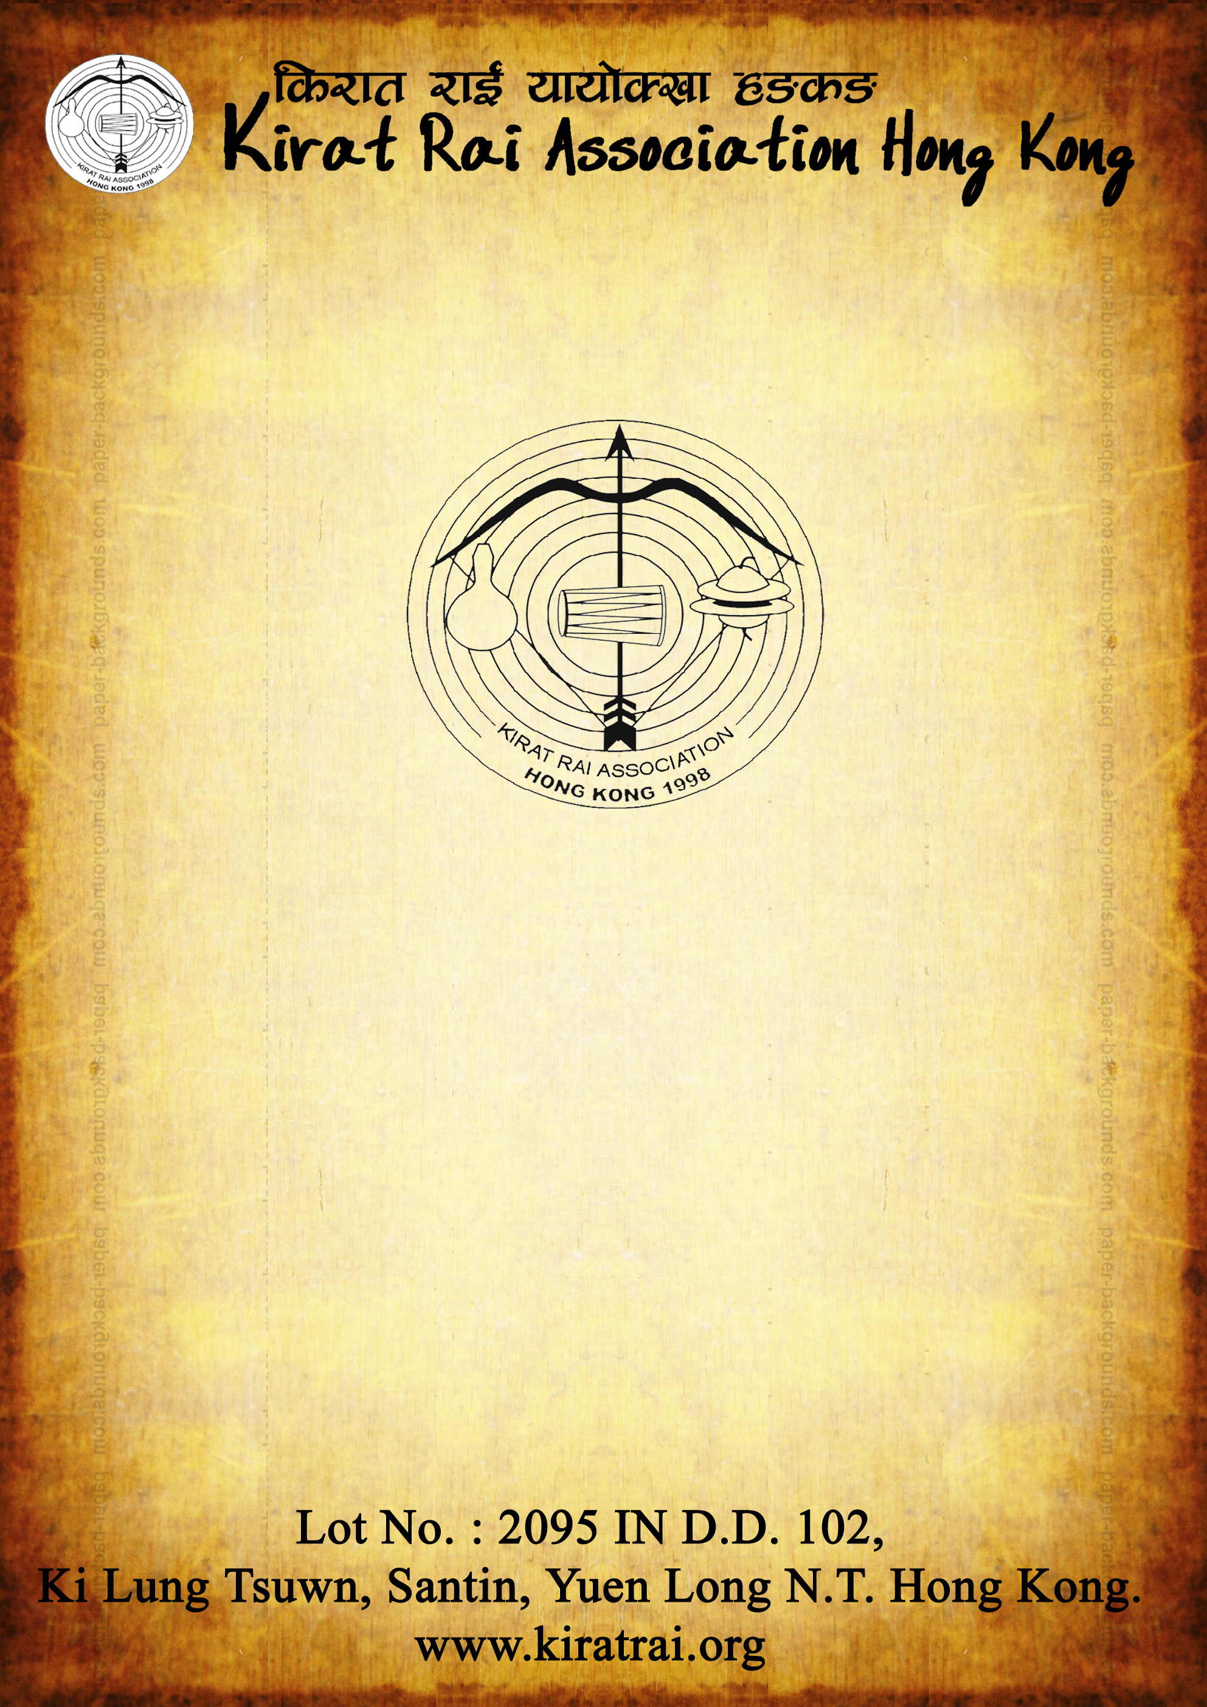
IDENTITY CARD

VOLUNTEER

Depart/Section:___________________________

Depart/Section in Chief: ___________________

IDENTITY CARD

VOLUNTEER

Depart/Section:___________________________

Depart/Section in Chief: ___________________


VICE-CHAIRMAN

COORDINATOR

Chamling Khambatim Hong Kong

Mrs. Pabitra Rai
VICE-CHAIRMAN

COORDINATOR

Chamling Khambatim Hong Kong

Mrs. Pabitra Rai

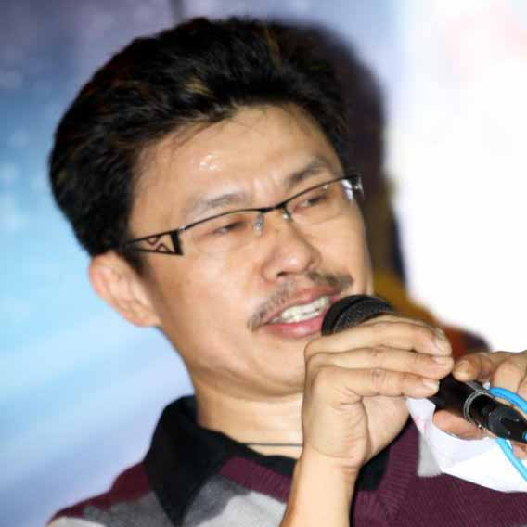
VICE-CHAIRMAN

COORDINATOR

Dumi Funsikim Hong Kong

Kamal Dumi Rai
VICE-CHAIRMAN

COORDINATOR

Dumi Funsikim Hong Kong

Kamal Dumi Rai

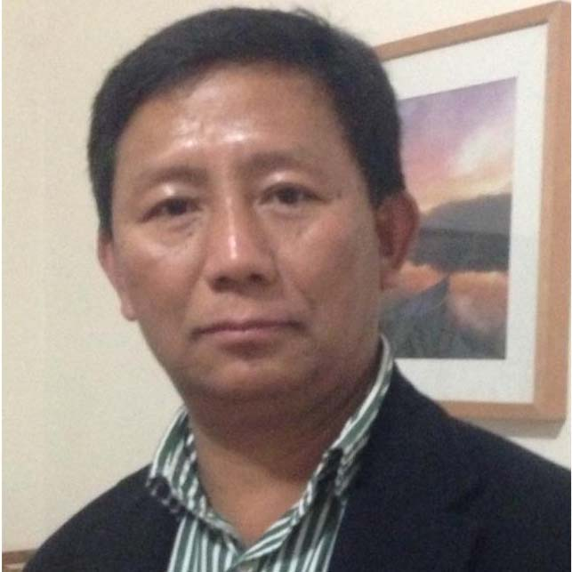
VICE-CHAIRMAN

MAIN COORDINATOR

Shipping, Storage & Logistic Depart
& Sampang Jumlekha Hong Kong

Tej Kumar Rai
VICE-CHAIRMAN

MAIN COORDINATOR

Shipping, Storage & Logistic Depart
& Sampang Jumlekha Hong Kong

Tej Kumar Rai

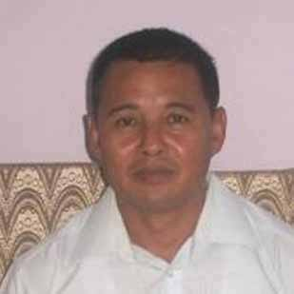
VICE-CHAIRMAN

MAIN COORDINATOR

Guest Caring & Hospitality Depart
& Bantawa Khim Hong Kong

Durga Kanta Rai
VICE-CHAIRMAN

MAIN COORDINATOR

Guest Caring & Hospitality Depart
& Bantawa Khim Hong Kong

Durga Kanta Rai

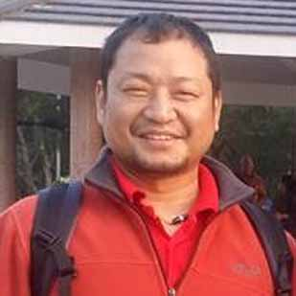
VICE-CHAIRMAN
MAIN COORDINATOR

Child, Women, Adult and Welcome Depart
& Puma Tupkha Bankhala Hong Kong
Penguin Puma Rai
VICE-CHAIRMAN
MAIN COORDINATOR

Child, Women, Adult and Welcome Depart
& Puma Tupkha Bankhala Hong Kong
Penguin Puma Rai

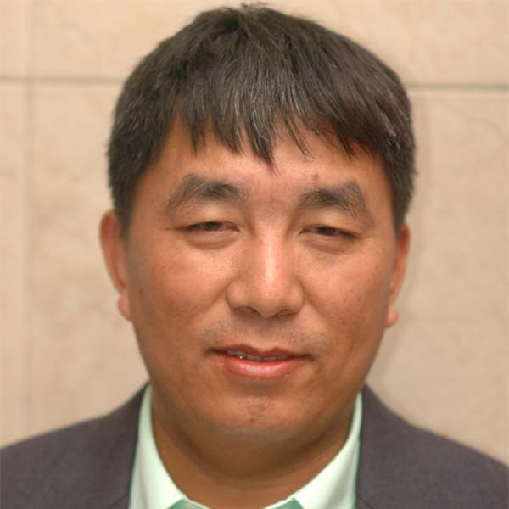
VICE-CHAIRMAN

MAIN COORDINATOR

Youth Sport, Music & Communication Depart
& Thulung Sama Hong Kong

Ram Lee Rai

VICE-CHAIRMAN

MAIN COORDINATOR

Youth Sport, Music & Communication Depart
& Thulung Sama Hong Kong

Ram Lee Rai

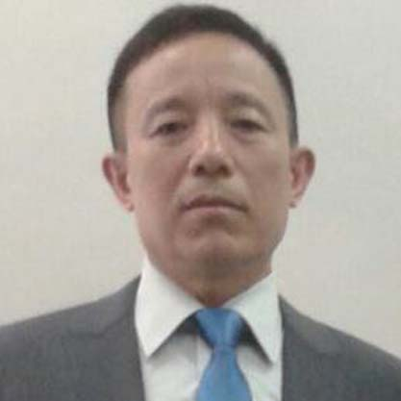
VICE-CHAIRMAN
MAIN COORDINATOR

Waste Collection & Sanitation Depart
& Sodel Koyu/Koyee Kim Hong Kong

Hita Bahadur Rai
VICE-CHAIRMAN
MAIN COORDINATOR

Waste Collection & Sanitation Depart
& Sodel Koyu/Koyee Kim Hong Kong

Hita Bahadur Rai

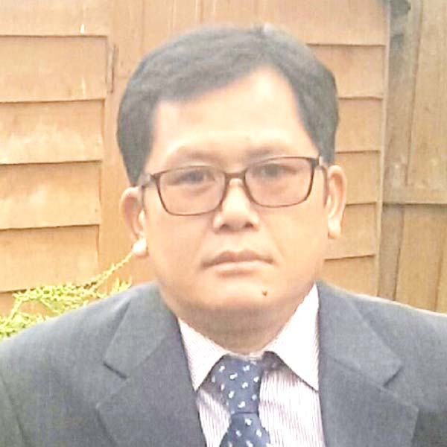
VICE-CHAIRMAN

MAIN COORDINATOR

Historical Collection & Decoration Depart
& Bahing Mulukhim Hong Kong

Lokharaj Rai
VICE-CHAIRMAN

MAIN COORDINATOR

Historical Collection & Decoration Depart
& Bahing Mulukhim Hong Kong

Lokharaj Rai

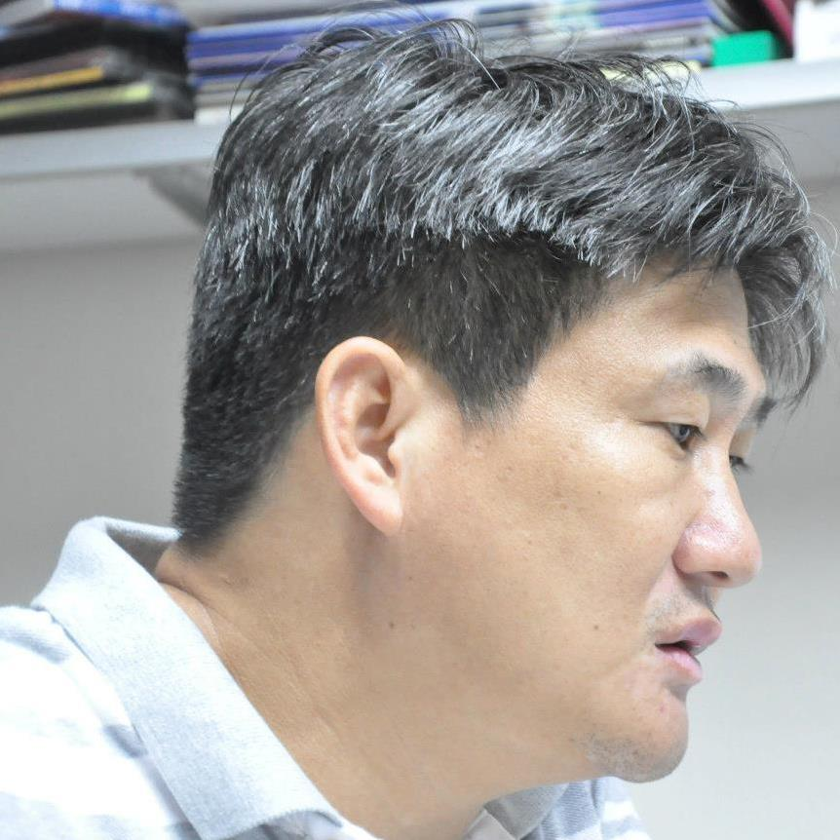
PATRON

MEMBER

Past Chairman Council
Kisan Rai
PATRON

MEMBER

Past Chairman Council
Kisan Rai

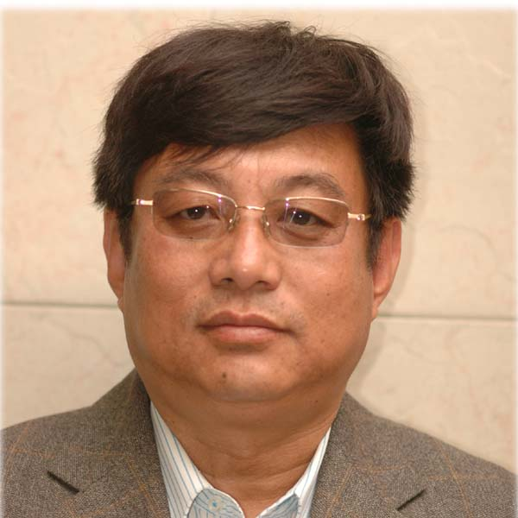
PATRON

MEMBER

Past Chairman Council
Hejen Rai

PATRON

MEMBER

Past Chairman Council
Hejen Rai

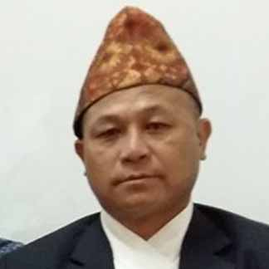
KUBIMI
COORDINATOR

Kirat Religion Protection & Ritual Depart

Narayan Prasad Rai
KUBIMI

COORDINATOR

Kirat Religion Protection & Ritual Depart

Narayan Prasad Rai

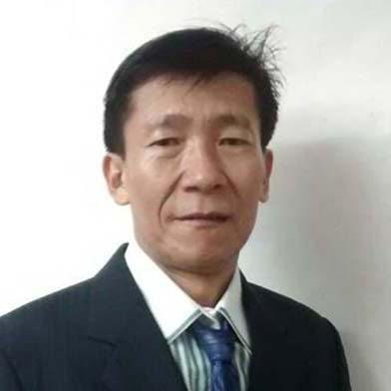
ASST. KUBIMI

COORDINATOR

Kirat Religion Protection & Ritual Depart

Maitra Kumar Rai
ASST. KUBIMI

COORDINATOR

Kirat Religion Protection & Ritual Depart

Maitra Kumar Rai

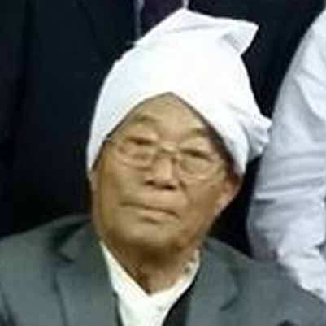
MAIN KUBIMI

MAIN COORDINATOR

Kirat Religion Protection & Ritual Depart

Shrestha Bahadur Rai
MAIN KUBIMI

MAIN COORDINATOR

Kirat Religion Protection & Ritual Depart

Shrestha Bahadur Rai

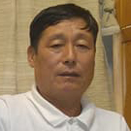
ASST. KUBIMI

COORDINATOR

Kirat Religion Protection & Ritual Depart

Adip Thulung Rai
ASST. KUBIMI

COORDINATOR

Kirat Religion Protection & Ritual Depart

Adip Thulung Rai

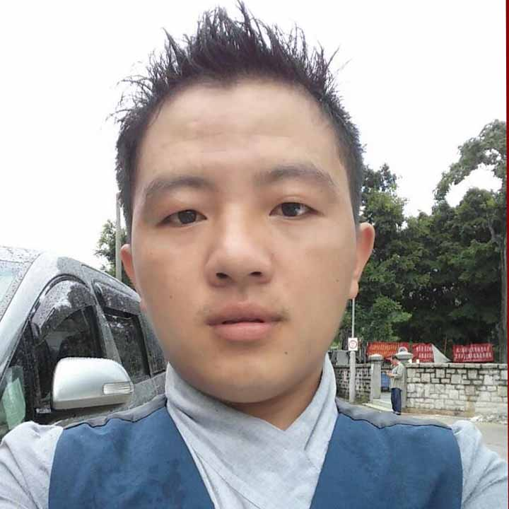
SILIMOPA
COORDINATOR

(Shili Presentation Section)
Shili Collection & Culture Depart

Rabi Chandra Rai
SILIMOPA

COORDINATOR

(Shili Presentation Section)
Shili Collection & Culture Depart

Rabi Chandra Rai


SILIMOMA

COORDINATOR

(Shili Presentation Section)
Shili Collection & Culture Depart

Renuka Rai
SILIMOMA

COORDINATOR

(Shili Presentation Section)
Shili Collection & Culture Depart

Renuka Rai

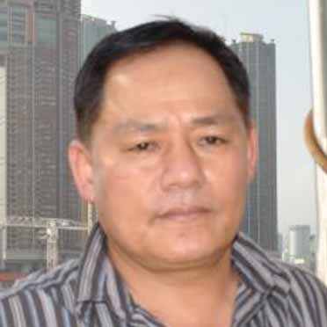
COORDINATOR

COORDINATOR

(BBQ SECTION)
Guest Caring & Hospitality Depart

Dhiraj Bantawa
COORDINATOR

COORDINATOR

(BBQ SECTION)
Guest Caring & Hospitality Depart

Dhiraj Bantawa

IDENTITY CARD

VOLUNTEER

Depart/Section:___________________________

Depart/Section in Chief: ___________________

IDENTITY CARD

VOLUNTEER

Depart/Section:___________________________

Depart/Section in Chief: ___________________

IDENTITY CARD

VOLUNTEER

Depart/Section:___________________________

Depart/Section in Chief: ___________________

IDENTITY CARD

VOLUNTEER

Depart/Section:___________________________

Depart/Section in Chief: ___________________

IDENTITY CARD

VOLUNTEER

Depart/Section:___________________________

Depart/Section in Chief: ___________________

IDENTITY CARD

VOLUNTEER

Depart/Section:___________________________

Depart/Section in Chief: ___________________

IDENTITY CARD

VOLUNTEER

Depart/Section:___________________________

Depart/Section in Chief: ___________________

IDENTITY CARD

VOLUNTEER

Depart/Section:___________________________

Depart/Section in Chief: ___________________

IDENTITY CARD

VOLUNTEER

Depart/Section:___________________________

Depart/Section in Chief: ___________________

IDENTITY CARD

VOLUNTEER

Depart/Section:___________________________

Depart/Section in Chief: ___________________

IDENTITY CARD

VOLUNTEER

Depart/Section:___________________________

Depart/Section in Chief: ___________________

IDENTITY CARD

VOLUNTEER

Depart/Section:___________________________

Depart/Section in Chief: ___________________

IDENTITY CARD

VOLUNTEER

Depart/Section:___________________________

Depart/Section in Chief: ___________________

IDENTITY CARD

VOLUNTEER

Depart/Section:___________________________

Depart/Section in Chief: ___________________

IDENTITY CARD

VOLUNTEER

Depart/Section:___________________________

Depart/Section in Chief: ___________________

IDENTITY CARD

VOLUNTEER

Depart/Section:___________________________

Depart/Section in Chief: ___________________

IDENTITY CARD

VOLUNTEER

Depart/Section:___________________________

Depart/Section in Chief: ___________________

IDENTITY CARD

VOLUNTEER

Depart/Section:___________________________

Depart/Section in Chief: ___________________

IDENTITY CARD

VOLUNTEER

Depart/Section:___________________________

Depart/Section in Chief: ___________________

IDENTITY CARD

VOLUNTEER

Depart/Section:___________________________

Depart/Section in Chief: ___________________

IDENTITY CARD

VOLUNTEER

Depart/Section:___________________________

Depart/Section in Chief: ___________________

IDENTITY CARD

VOLUNTEER

Depart/Section:___________________________

Depart/Section in Chief: ___________________

IDENTITY CARD

VOLUNTEER

Depart/Section:___________________________

Depart/Section in Chief: ___________________

IDENTITY CARD

VOLUNTEER

Depart/Section:___________________________

Depart/Section in Chief: ___________________

IDENTITY CARD

VOLUNTEER

Depart/Section:___________________________

Depart/Section in Chief: ___________________

IDENTITY CARD

VOLUNTEER

Depart/Section:___________________________

Depart/Section in Chief: ___________________

IDENTITY CARD

VOLUNTEER

Depart/Section:___________________________

Depart/Section in Chief: ___________________

IDENTITY CARD

VOLUNTEER

Depart/Section:___________________________

Depart/Section in Chief: ___________________

IDENTITY CARD

VOLUNTEER

Depart/Section:___________________________

Depart/Section in Chief: ___________________

IDENTITY CARD

VOLUNTEER

Depart/Section:___________________________

Depart/Section in Chief: ___________________

IDENTITY CARD

VOLUNTEER

Depart/Section:___________________________

Depart/Section in Chief: ___________________

IDENTITY CARD

VOLUNTEER

Depart/Section:___________________________

Depart/Section in Chief: ___________________

IDENTITY CARD

VOLUNTEER

Depart/Section:___________________________

Depart/Section in Chief: ___________________

IDENTITY CARD

VOLUNTEER

Depart/Section:___________________________

Depart/Section in Chief: ___________________

IDENTITY CARD

VOLUNTEER

Depart/Section:___________________________

Depart/Section in Chief: ___________________

IDENTITY CARD

VOLUNTEER

Depart/Section:___________________________

Depart/Section in Chief: ___________________

IDENTITY CARD

VOLUNTEER

Depart/Section:___________________________

Depart/Section in Chief: ___________________

IDENTITY CARD

VOLUNTEER

Depart/Section:___________________________

Depart/Section in Chief: ___________________

IDENTITY CARD

VOLUNTEER

Depart/Section:___________________________

Depart/Section in Chief: ___________________

IDENTITY CARD

VOLUNTEER

Depart/Section:___________________________

Depart/Section in Chief: ___________________

IDENTITY CARD

VOLUNTEER

Depart/Section:___________________________

Depart/Section in Chief: ___________________

IDENTITY CARD

VOLUNTEER

Depart/Section:___________________________

Depart/Section in Chief: ___________________

